**WELDING SYMBOLS**

**INTRODUCTION**

**Welding symbols are used on blueprints and drawings to show where the weld is to be placed and may also show the size, type of weld, number of welds, details about the weld and even details about the joint.**

**Welders that fabricate or work with drawing must be able to interpret the welding symbol to prepare the joint and apply a weld that has the required strength and soundness.**

**THE REFERENCE LINE AND ARROW**

**The reference line is one of the most important elements on the welding symbol. All the other elements that describe the weld are on or located around this line. The reference line has a leader and arrow that points to where the information applies. It may also have a tail that has information about the process, specification, or other notes that do not normally have an element that describes them. If the elements on the reference line describe the necessary details (as it does in most cases) the tail is not used.**

**See the examples below:**

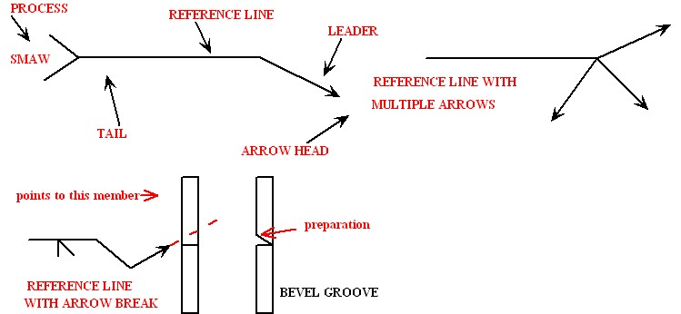

**In the above examples one of the reference lines has multiple arrows that are used to show the same weld in three locations that are relatively close to each other. There is also a reference line that has an arrow break. The break in the arrow is used to indicate the joint member that is to receive the edge preparation.**

**KEY POINT: the arrow points to the bevel where the bevel needs to be prepared.**

**ARROW SIDE**

**One of the most important things about the reference line and the welding symbol is the top and bottom of the horizontal line. The actual symbol that shows the type of weld and the elements surrounding it that detail the weld can be placed on the top of the line or on the bottom of the line.**

**KEY POINTS: symbols on the bottom of the reference line mean weld the side of the joint the arrow is touching or pointing to. Symbols on the top of the reference line mean apply the weld to the other side of the joint, or the side opposite to where the arrow is pointing.**

**This method is used because sometimes the welding symbol must be drawn on the blueprint on the other side of the joint. When symbols appear on both sides of the reference line it means weld both sides of the joint.**

**If the reference line has a weld symbol on both sides of the reference line they may, or may not be the same weld on both sides of the joint. Remember the rule to apply the right weld to the right side.**

**See the examples:**

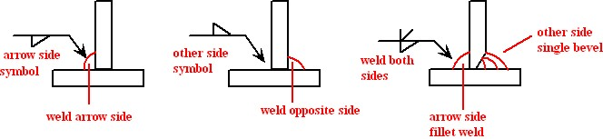

**OTHER ELEMENTS ON REFERENCE LINE**

**There are two other elements that may be seen on the reference line that provide information about the weld. One is a circle around the place where the leader line connects to the reference line and indicates the weld is “ALL AROUND”. This means the weld extends all the way around the joint the arrow is pointing at.**

**KEY POINT: The all around element is only used when it is possible to weld all the way around a single surface. Otherwise more than on symbol is used.**

**The other element seen on the reference line resembles a flag and is located where the leader line joins the reference line.  This element is called a field weld and means the weld will be done in another location. For instance, this weld may be applied at the job site not in the shop. Sometimes clarification will be given in the welding symbol tail or as a specification on the print.**

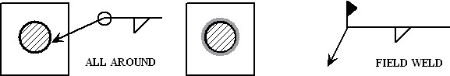

**THE FILLET WELD**

**The fillet weld symbol is one of the most widely used symbols and the shape placed on the reference line to indicate a fillet weld is a triangle that resembles the side profile of a fillet weld.**

**The examples of the weld all around and field weld above show a fillet weld symbol so that the weld to be applied in both cases is a fillet weld.**

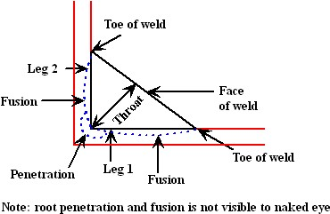

**The names of the parts of the fillet weld**

**KEY POINT: Fillet sounds like fill it (pronounce the T) not fillay as in fillet a fish.**

**The important elements added to a simple fillet weld symbol are as follows;**

1. **The size of the weld.**
2. **The length of the weld.**
3. **The length and pitch OF INTERMITTENT welds.**
4. **The contour requirements.**

1. **THE SIZE OF THE WELD.**

**The size of the fillet weld is determined by the legs of the triangle shape which represent the legs of the fillet.**

**A welded piece may have a different weld size on each side or they may be the same size.**

**Sometimes (not often) a weld of unequal legs may be required. For example: if one member of the joint is thinner than the other.**

**If no size is shown on the fillet weld, a size for all fillets will be given on the drawing as a note or specification.**

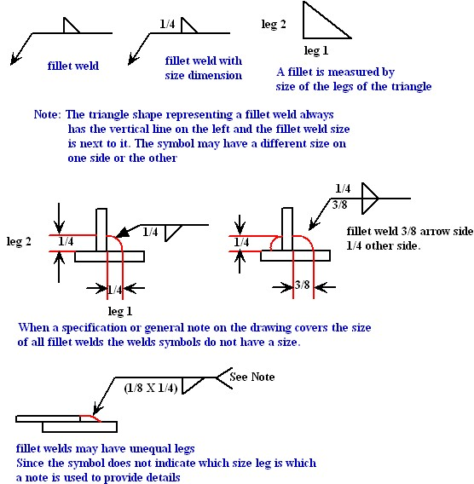

**KEY POINT: Making the fillet welds the wrong size may lead to costly rework if you are not sure ask for clarification.**

**2.**      **THE LENGTH OF THE FILLETWELD.**

**The length of the weld when it is not a continuous weld is shown by a number on the right side of the fillet weld triangle. If it is not obvious the location is detailed on the drawing.**

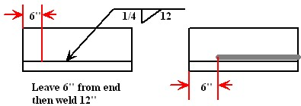

**3.**      **THE LENGTH AND PITCH OF INTERMITTENT WELDS**

**An intermittent weld is one that is not continuous across the joint, but rather is a given length of weld separated by a given space between them. This method of welding may be used to control heat distortion or where the joint strength requirements allow. Intermittent welding can save time and money if a long weld is not necessary.**

**Used more frequently than the length alone, the length and pitch are two numbers located at the right of the fillet weld symbol.**

**The length appears first as before followed by a hyphen then the pitch is shown.**

**The pitch refers to a dimension from the center of one weld to the center of the next weld.**

**KEY POINT: The pitch is not the space between welds but a measurement from center to center of the welds. To get the spacing for layout subtract the length of one weld from the pitch.**

**The intermittent welds may be chain intermittent or staggered intermittent. Chain intermittent the welds on both sides of the joint are opposite each other and resemble a chain. Staggered intermittent the welds on the opposite side are usually started in the gap between the welds on the first side. The welds then appear staggered.**

**KEY POINT: If the welds are staggered the fillet weld symbol will be staggered on the reference line.**

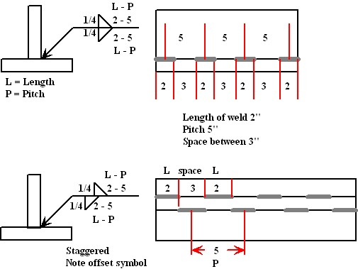

1. **THE CONTOUR REQUIREMENTS**

**Some welding symbols may show a contour finish that details how the fillet weld shape must be finished after welding.  The contour may be flat or convex and the element to describe this is placed above the slope on the fillet weld symbol. A letter to indicate the method of finish may be given above the finish element.**

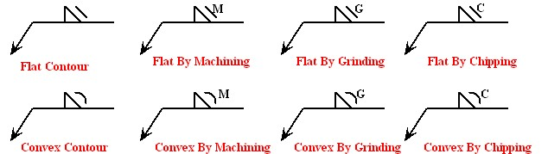

**A letter U may be used to designate an unspecified finish, when the choice of finishing is given.**

**SUMMARY**

**When reading a fillet weld symbol always make sure you know what side of the joint the weld is applied to. Fillet weld symbols on the bottom of the reference line mean apply the weld to the side of the joint the arrow points to. Fillet weld symbols on the top of the reference line mean apply the weld to the opposite side of the joint. Fillet weld symbols on both sides of the reference line mean apply weld to both sides of the joint. This remains the case regardless of how the break in the arrow is drawn.**

**The size of a fillet weld is determined by the length of the leg of the fillet weld and is shown on the symbol to the left.**

**If two numbers appear in parenthesis the legs are unequal, check the drawing for clarification.**

**When a length of weld is shown on a fillet weld symbol the dimension is placed on the right side.**

**When two numbers appear separated by a hyphen, the length is indicated first then the pitch. The pitch is the distance from the center of one length of weld to the center of the next length of weld.**

**When finishing directions are shown they appear over the slope of the fillet weld symbol.**

**GROOVE WELDING SYMBOLS**

**Groove welding symbols are used to show how butt joints are prepared for welding and to detail how the weld is to be applied. When two pieces of metal, other than sheet metal or thin sections, are butted together for welding they usually have some form of a groove to allow the weld to penetrate into or through the joint.**

**The groove is formed by preparing the edges to be welded with a bevel edge, chamfer edge, double bevel edge, J groove edge or double j groove edge.**

**When the butt joint has no edge preparation it is referred to as a square groove.**

**The typical edge preparations are shown below:**

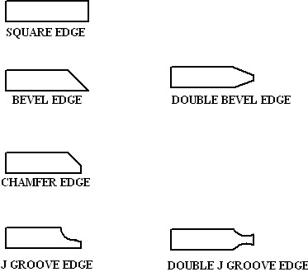

**The edge preparations may be assembled as either open root, with a backing bar or by utilizing the back weld or backing weld application.**

**The open root assembly allows penetration through the joint, while the backing bar is used for easier welding. The backing bar may be removed or may be a part of the joint.**

**The backing weld is applied before welding and acts as a backing bar, while the back weld is applied after welding to finish the back side of the joint. Before applying the back weld a grinder or other method may be used to prepare a V.**

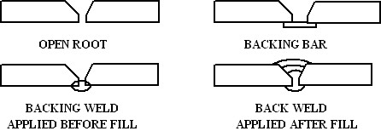

**The edge preparations may be assembled in any configuration to form the groove for welding from either one side or both sides. The most common configurations and their basic symbols are shown below.**

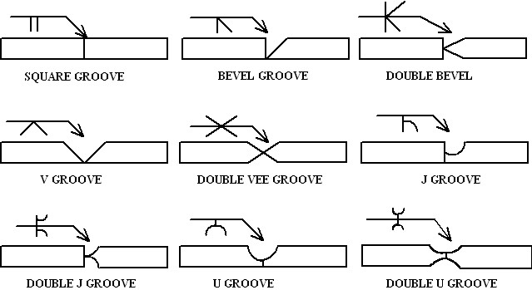

**KEY POINT: If two imaginary lines are drawn parallel to the horizontal line in the above symbols they show the joint shape, this is true for most of the symbols. This can be helpful to remember since symbols on a blueprint do not show the actual joint shape or edge preparation.**

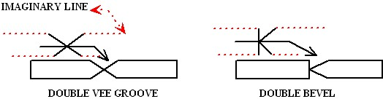

**KEY POINT: The Groove welding symbols have the same placement relevance on the reference line as the fillet weld. Symbols on the bottom of the reference line mean weld the side of the joint the arrow is touching or pointing to, while symbols on the top of the reference line mean weld the opposite side of where the arrow is touching or pointing to.**

**If it is not clear always ask someone; reworking welds is costly and time consuming.**

**GROOVE WELDING ELEMENTS**

**GROOVE WELD SIZE**

**The groove weld size is given in two dimensions and like the fillet weld it is placed to the left of the weld symbol.**

**The first size given is THE DEPTH OF GROOVE and is the dimension used to prepare the edge preparation.**

**The depth of groove is measured from the surface of the joint to the bottom of the preparation.**

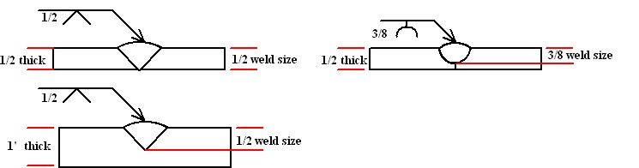

**KEY PONT: The depth of groove does not include weld reinforcement or root penetration.**

**The second size given is the ACTUAL WELD SIZE and is enclosed in parentheses to distinguish it from the groove size, or depth of groove.**

**The actual weld size is again measured from the surface of the groove through the bottom of the groove but now includes the expected penetration of the weld. On a square groove only the weld size is given.**

**The weld size does not include face reinforcement or root reinforcement.**

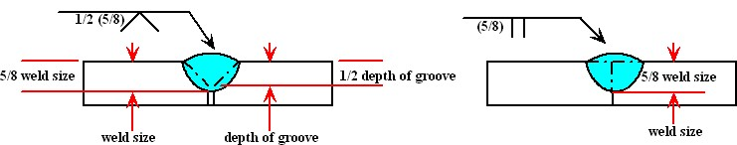

**KEY POINT: The penetration into the joint shown on the weld size is not measurable by the naked eye but is given to provide information about the expected outcome.**

**ROOT OPENING AND GROOVE ANGLE**

**Two other important elements for preparing and welding the groove are the root opening and the groove angle.**

**The root opening, when used, dimensions the space between the joint to be welded and is placed inside the weld symbol.**

**The groove angle is also placed inside the weld symbol and is given in degrees.**

**KEY POINT: The groove angle for a V groove is given as the INCLUDED angle so that means the edge bevel or chamfer for each piece is 1/2 of the degrees given. For example; A 45 degree included angle means bevel each member at 22 1/2 degrees.**

**J grooves angles may be detailed elsewhere on the drawing.**

**The root opening and groove angle are separate elements and may or may not appear together depending on the joint requirements.**

**On some drawings the root opening or groove angle will be covered in a note or specification on the drawing for all similar symbols, and does not appear on the symbol.**

**The Welder must always read all information given on a drawing.**

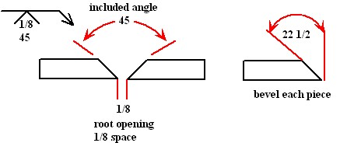

**CONTOUR AND FINISHING**

**The same contour symbols that apply to fillet welds may be used with groove welding and are placed above the weld symbol.**

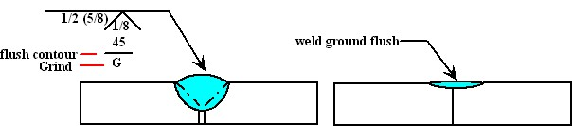

**BACKING BARS BACK WELDS AND SPACERS**

**As previously mentioned in this section some joint configurations may have a backing bar or spacer for easier welding or may employ the back or backing weld technique.**

**The elements for these are placed on the bottom of the reference line opposite the weld symbol or in the case of the spacer on the reference line.**

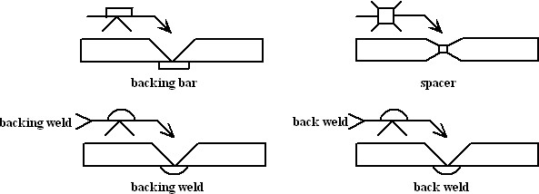

**KEY POINT: If the backing bar is to be removed the symbol will contain an R for remove after welding.**

**Since the back and backing weld symbol look the same you must look for details to see which weld applies.**

**Spacers may be removed before the second side is welded or they may become part of the joint.**

**SUMMARY**

**The groove weld symbols are used to provide information for preparing and welding the groove; however, they cannot always show every intended operation and often notes or specifications are used on the drawing. The welder should read the entire drawing before making a weld to avoid costly rework. Whenever you see something you are unfamiliar with check with engineering or supervision for clarification.**

**It is critical to produce the right size fillet and groove weld for the application so check sizes with weld gages**